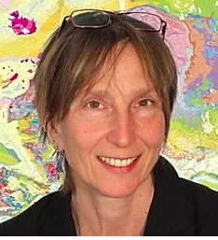
Vice President (2016-2020)
Dr. Kristine Asch
BGR - Federal Institute for Geosciences and Natural Resources
Unit Head Geological Information Systems and Maps
Stilleweg 2, 30655 Hannover
GERMANY
Tel: +49 (0) 511 643 -3324
Fax: +49 643 - 53 - 3324
Email: Kristine.Asch@bgr.de
Key Qualifications:
Dr. rer nat, geologist, is in charge of the “Geological Information Systems and Maps” unit at the Federal Institute for Geosciences and Natural Resources (BGR). She is Vice-president of the IUGS and is past Chair of the Commission of Geoscience Information (CGI). She has initiated and coordinated the IUGS CGI & UNESCO Geoscience InfoRmation in AFrica network (GIRAF) with to-date more than 300 members. Kristine authored the 1 : 5 Million International Geological Map of Europe and Adjacent Areas as web-enables geoinformation system and paper map and currently coordinates and compiles the GIS map of the Quaternary geology of Europe with international partners. She is Leader of the Work package Sea floor geology of the EMODnet Geology project since 2009. leads the Subcommission Europe of the Commission of the Geological Map of the World. As leader of the former German Geoscience INSPIRE Expert Group and member of the EU Drafting Team “Data Specifications” and the EU Thematic Working Group Geology and Mineral Resources, Kristine was intensely involved in creating the implementation rules “Geology” of the EU Directive INSPIRE.

